**EXP 12** Create a Virtual Machine with 1 CPU, 2GB RAM and 15GB storage disk using a Type 2 Virtualization Software

**PROCEDURE:**

**STEP 1:** Install VM ware software

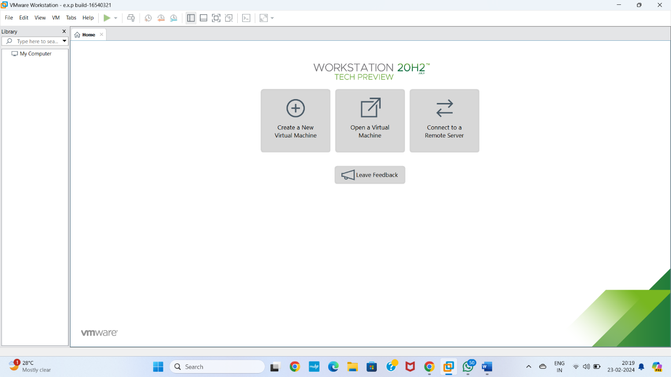

**STEP 2** CREAT A NEW VIRTUAL MACHINE GIVE NEXT

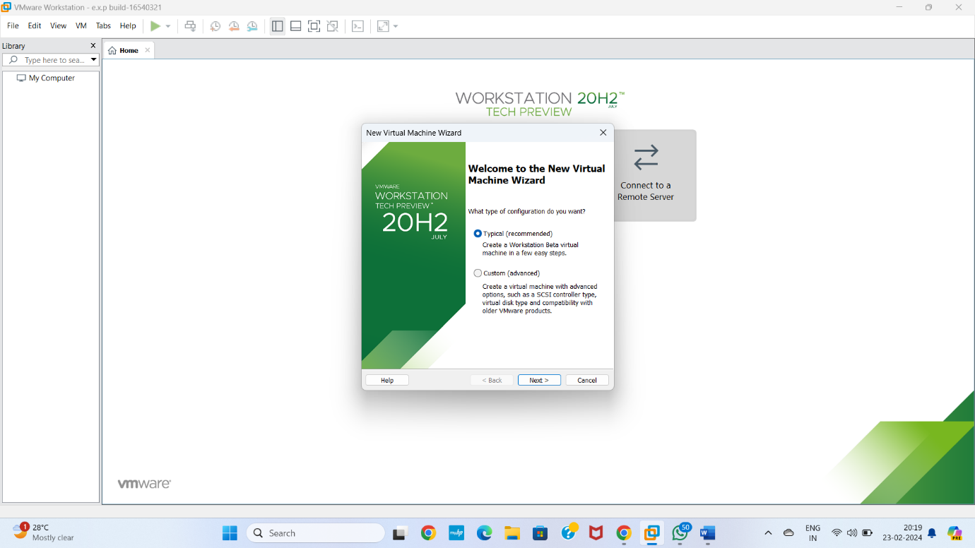

**STEP 3** Select I will install operating system later Give next

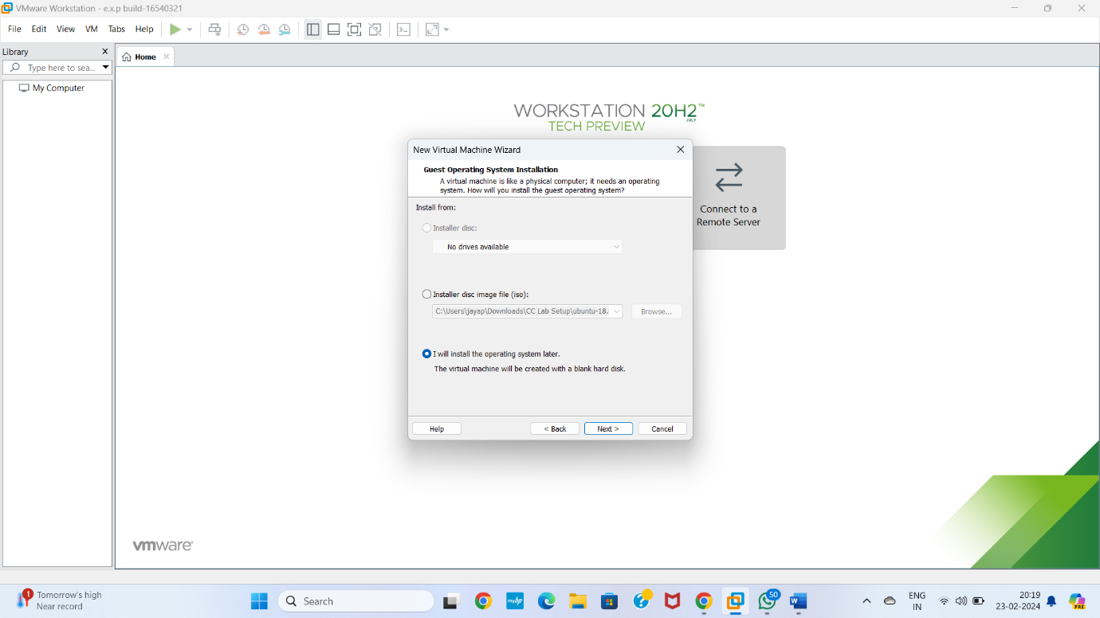

**STEP 4** Select gust operating system Give next

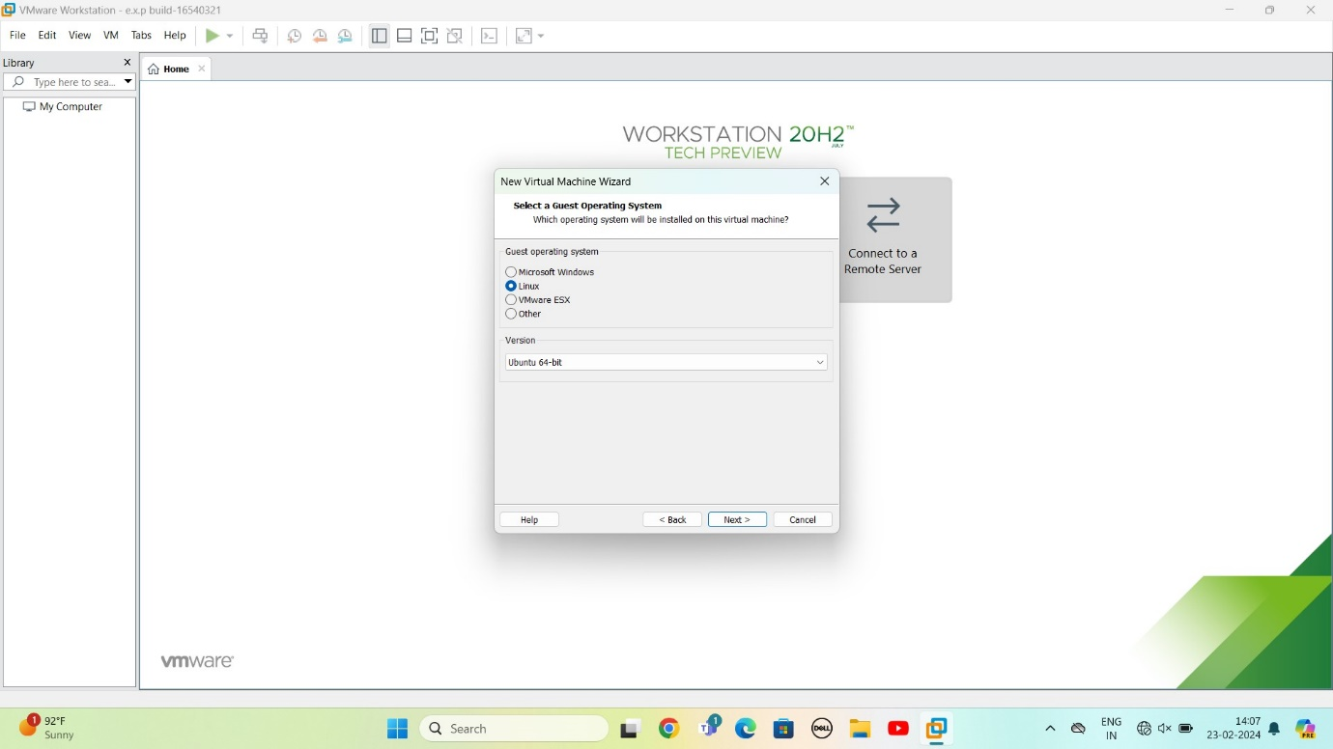

**STEP 5** selects name of virtual machine Give next

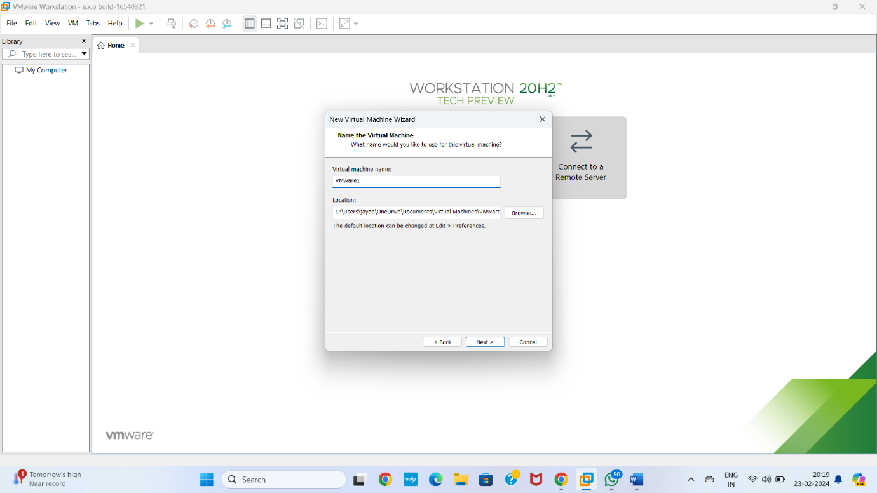

**STEP 6** selects the data storing disk and maximum size of disk

IN question they given maximum size=15.0 change value

Give next

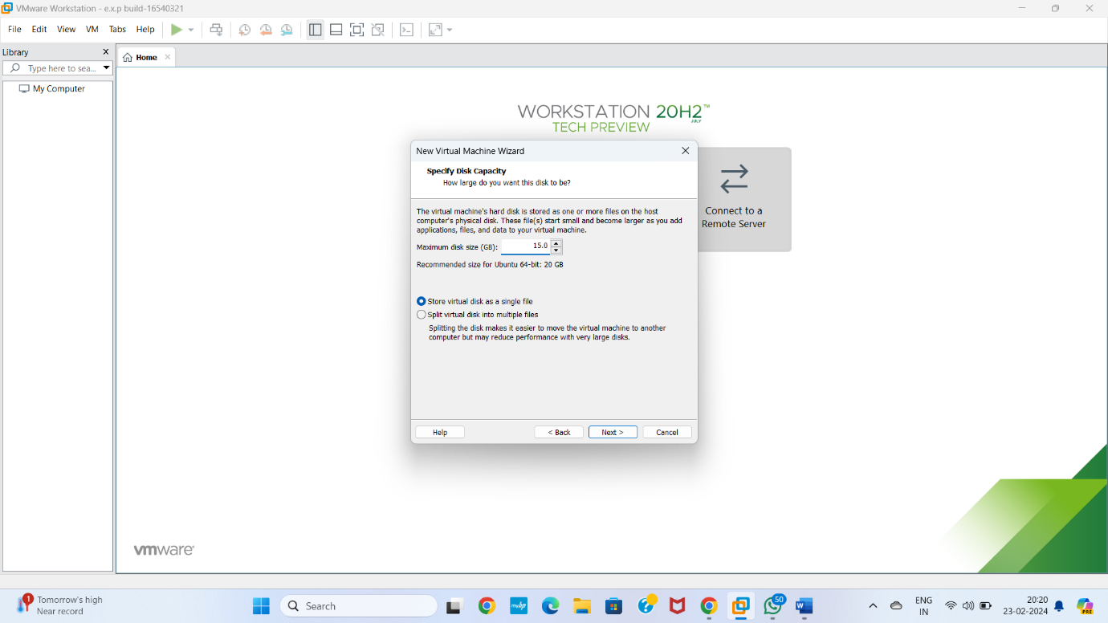

**STEP 7** Ready to create virtual machine Give finish

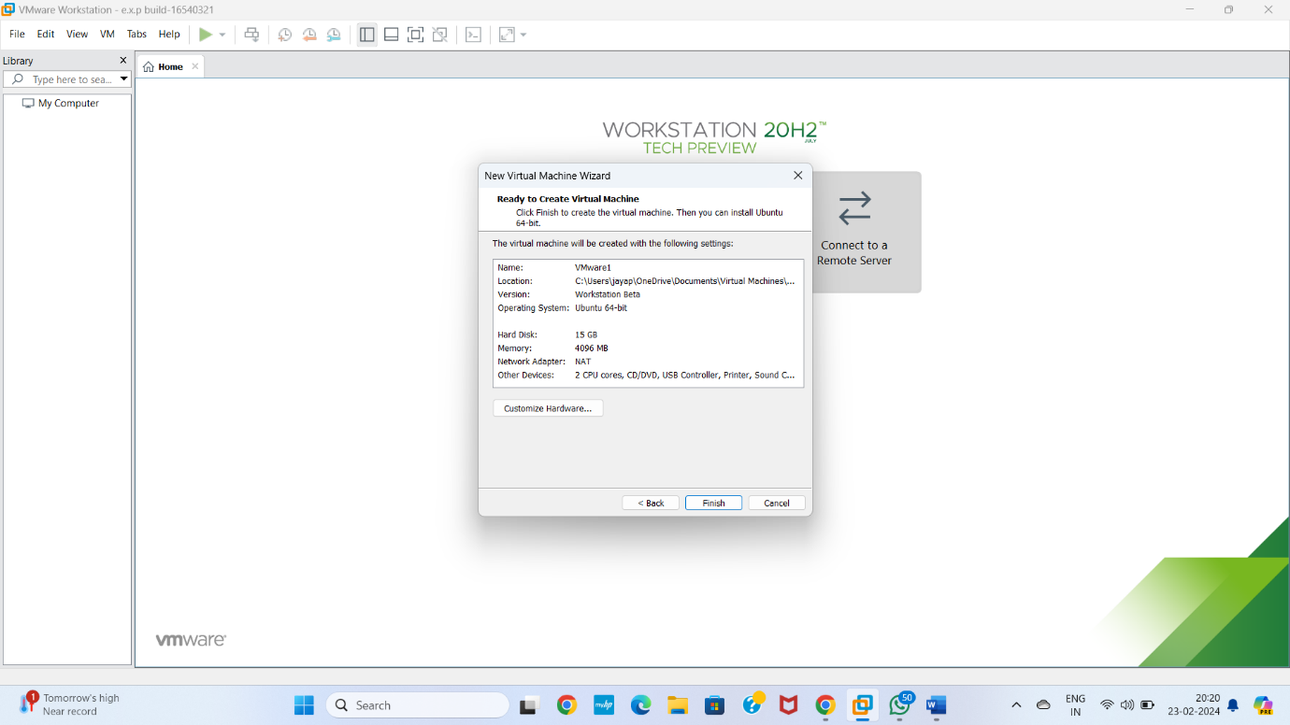

**STEP 8** VIRTUAL MACHINE CREATED

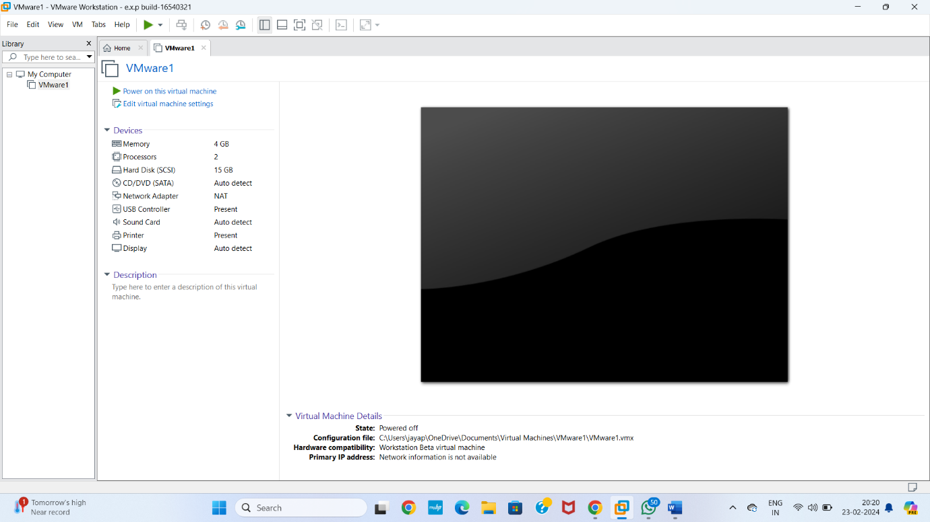

**STEP 9** change RAM=2gb and complete virtual machine as per given question

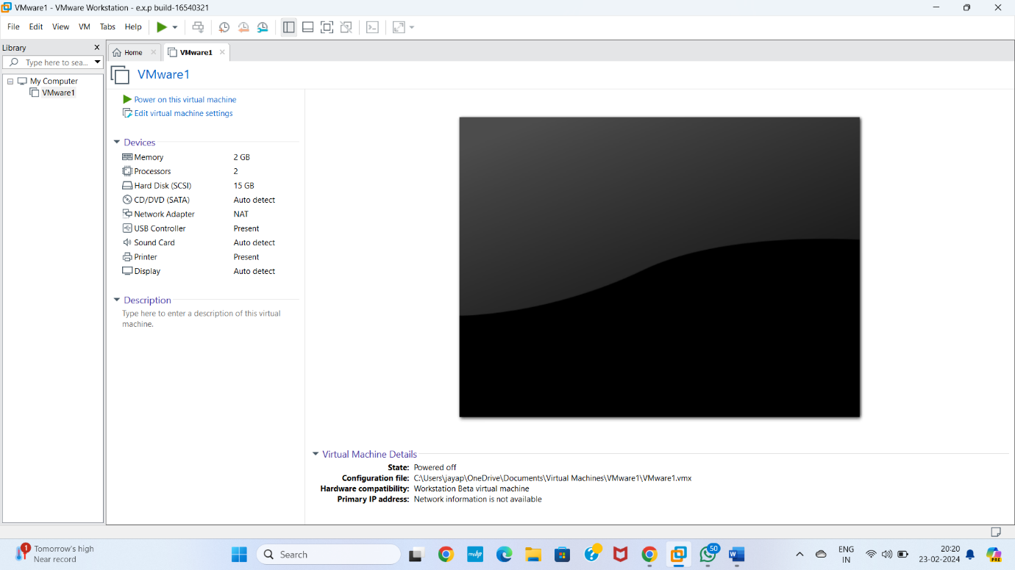

**STEP 9** In problem they given CPU value =1 Change according to it

